Supplement Materials

Details of KKT conditions
In III.B.2, KKT conditions are utilized to transform convex problem (27)-(31) into an equal form (32)-(38). The mathematical derivation process is detailed in this part.
Suppose at time $t$, there are $N_{m}$ EVs connected with EVA $m$. For EV $w$, the actual power $p_{w}(t)$ is yet to be determined, and $p_{m}\left(t\right)$ is a column vector composed of the $p_{w}(t)$ of each EV.
Among (32)-(38), (32) is the Lagrange function of convex optimization problem (27)-(31); (34) and (35) are complementary slackness conditions, where column vector $μ_{m,t}^{∨}$ and $μ_{m,t}^{∧}$ are composed of the slack variable of each EV’s upper power constraint and lower upper constraint, respectively, and it’s obvious that both $μ_{m,t}^{∨}$ and $μ_{m,t}^{∧}$ are $N_{m}$-dimensions; $ζ_{t}$ is a scalar Lagrange multiplier along with equation constraint (30).
As for (33), (37) and (38), the mathematical derivation process is detailed as follows:
Derive the partial derivative of Lagrange function to $p_{w}$:
Since only $p_{w},μ_{w,t}^{∨},μ_{w,t}^{∧}$ and $ζ_{t}$ in (71) are variables to be determined, $\frac{∂L}{∂p_{w}}$ can be simplified by introducing $a_{w,t}^{CA}$ and $b_{w,t}^{CA}$. Notably, both $a_{w,t}^{CA}$ and $b_{w,t}^{CA}$ are unique constant relevant to EV $w$, and each EV can generate a corresponding derivative equation with corresponding parameter $a_{w,t}^{CA}$ and $b_{w,t}^{CA}$, thus forming (33), (37) and (38).

Power profiles of different adjustable flexible units
In our modified 33-bus system, there are 3 EVCSs and 4 DGs, with DG4 designated as the “critical DG” of the whole system. The daily flexible range & the actual power of DG4 have been shown in Fig.4. For the rest of the adjustable units, the inherent flexible range, the forced flexible range and the actual disaggregated power (as the results of the enhanced expert module) of them are displayed here.
- Flexible range and dispatch power of different EVCSs in the modified 33-bus system
- Flexible range and dispatch power of different DGs in the modified 33-bus system
In our modified 141-bus system, there are 6 EVCSs and 8 DGs, with DG8 designated as the “critical DG” of the whole system. The daily flexible range & the actual power of DG8 have been shown in Fig.6. For the rest of the adjustable units, the inherent flexible range, the forced flexible range and the actual disaggregated power (as the results of the enhanced expert module) of them are displayed here.
- Flexible range and dispatch power of different EVCSs in the modified 141-bus system
- Flexible range and dispatch power of different DGs in the modified 141-bus system

Value of net load fluctuations
TABLE XI
Imposed Net Load Increase of Case 1
Time period | Total net load increase (p.u.) | Time period | Total net load increase (p.u.)
11:30~11:45 | 2.5800 | 12:30~12:45 | 2.5050
11:45~12:00 | 2.6475 | 12:45~13:00 | 2.7700
12:00~12:15 | 2.8500 | 13:00~13:15 | 1.7800
12:15~12:30 | 2.7350
TABLE XII
Imposed Net Load Decrease of Case 2
Time period | Total net load increase (p.u.) | Time period | Total net load increase (p.u.)
18:45~19:00 | -3.7250 | 19:45~20:00 | -4.3750
19:00~19:15 | -4.5925 | 20:00~20:15 | -4.7850
19:15~19:30 | -5.4950 | 20:15~20:30 | -2.8650
19:30~19:45 | -4.6900

TABLE XIII
Imposed Net Load Increase of Case 4
Time period | Total net load increase (p.u.) | Time period | Total net load increase (p.u.)
11:30~11:45 | 34.8500 | 12:30~12:45 | 41.3200
11:45~12:00 | 41.3200 | 12:45~13:00 | 37.9700
12:00~12:15 | 41.3200 | 13:00~13:15 | 41.3200
12:15~12:30 | 37.9700
TABLE XIV
Imposed Net Load Decrease of Case 5
Time period | Total net load increase (p.u.) | Time period | Total net load increase (p.u.)
18:45~19:00 | -34.8500 | 19:45~20:00 | -41.3200
19:00~19:15 | -41.3200 | 20:00~20:15 | -37.9700
19:15~19:30 | -41.3200 | 20:15~20:30 | -41.3200
19:30~19:45 | -37.9700

Training curves of our proposed safe DRL algorithm
To compare the convergence speed of M5~M9 in both the IEEE-33 and IEEE-141 bus system, the return curve of the DSO agent, the daily average IPDEV curve, the maximal voltage violation curve and the maximal power flow violation curve are presented here – it’s worth noting that, apart from return, the other three selected indicators are nearly identical to the ones we adopt in TABLE III and TABLE IX of Section V, which offers a comprehensive glimpse into security maintenance conditions in the distribution network.
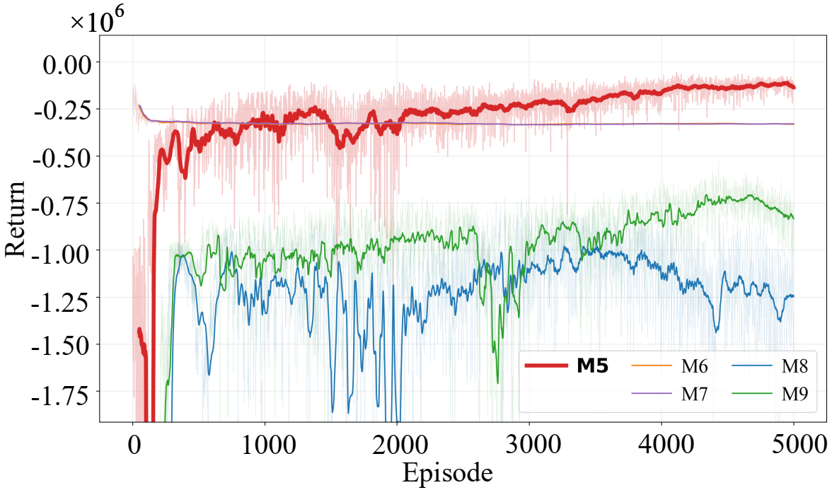 | 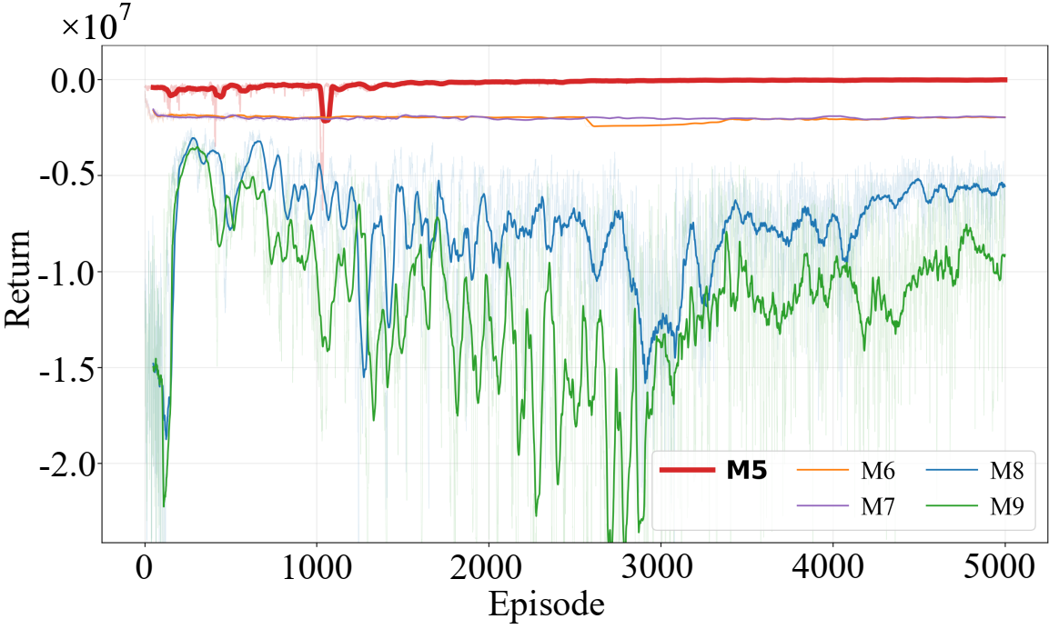
(a1) Convergence curve of return (33-bus) | (a2) Convergence curve of return (141-bus)
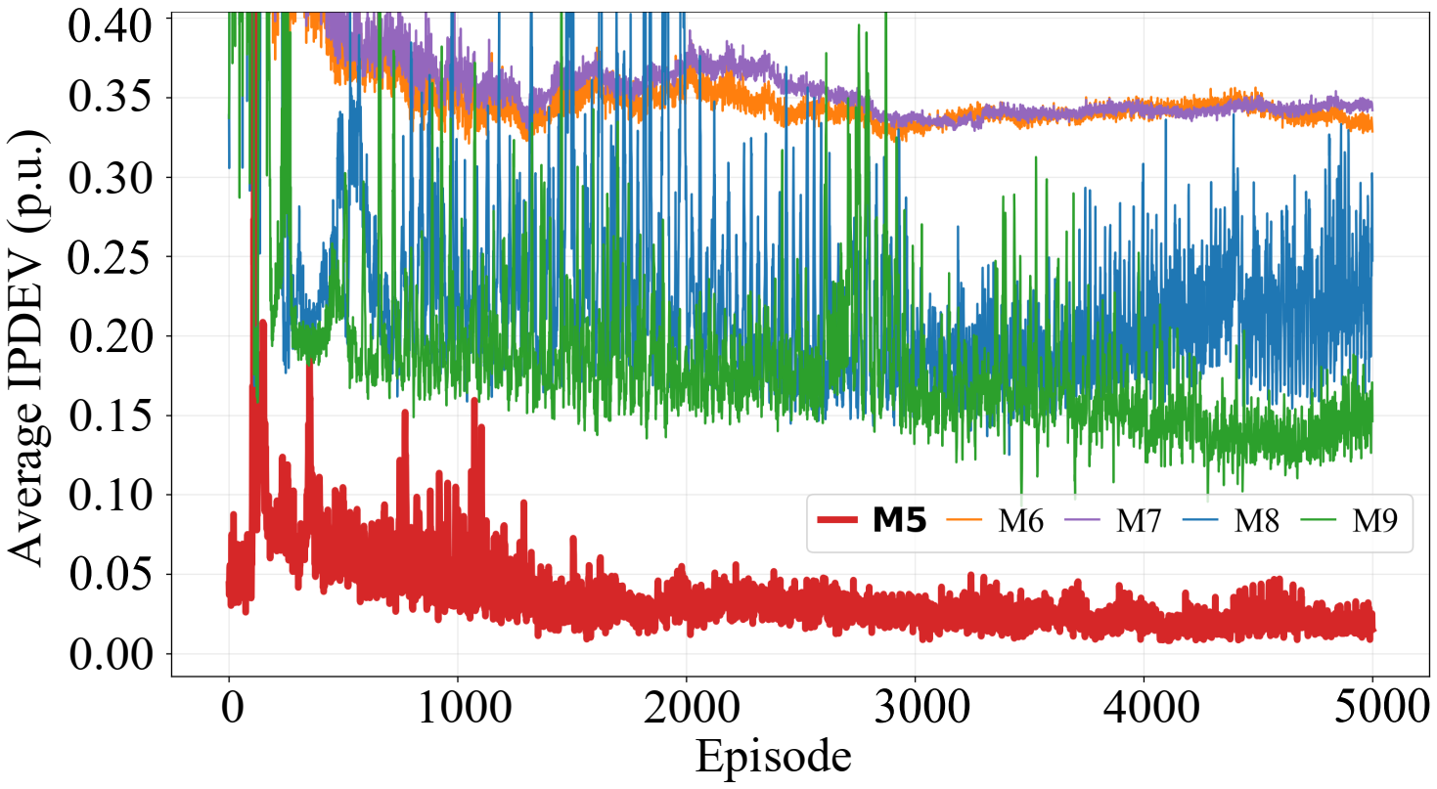 | 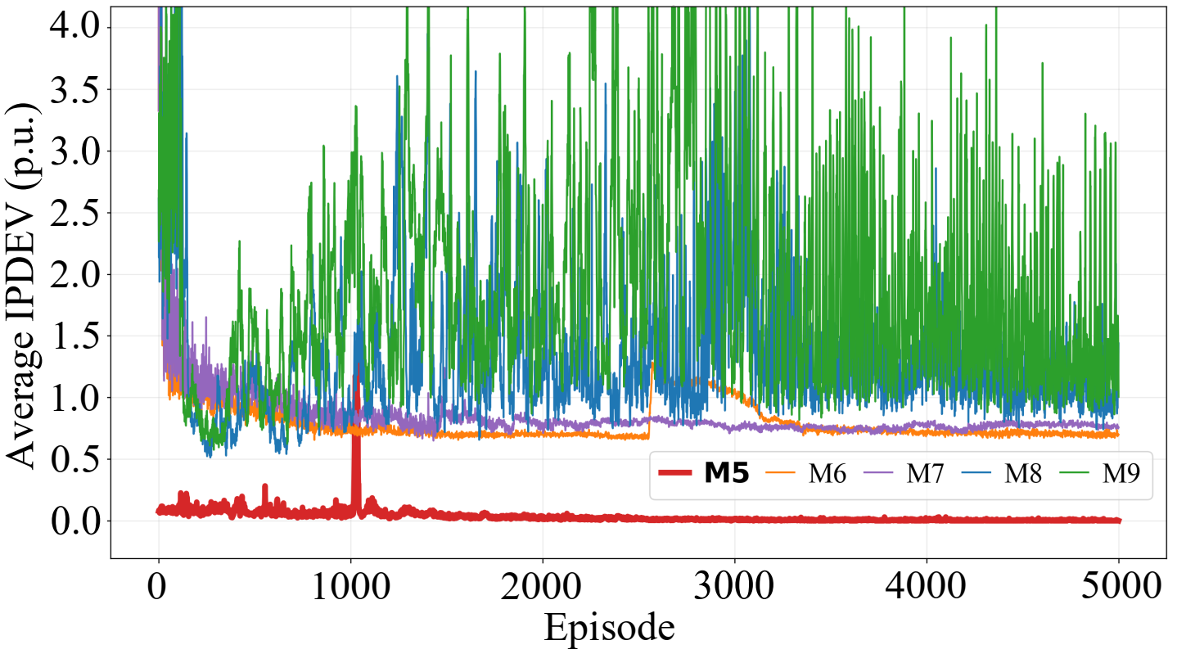
(b1) Average IPDEV (33-bus) | (b2) Average IPDEV (141-bus)
- Convergence return and IPDEV curves of M5~M9 in the modified IEEE-33 and IEEE-141 bus system
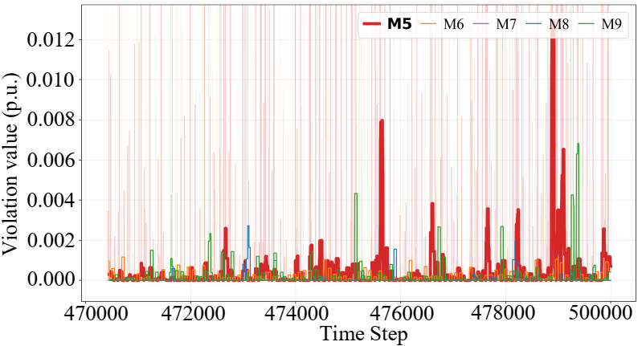 | 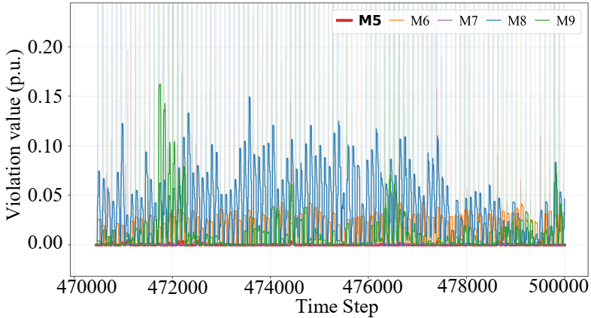
(c1) Maximal voltage violation of the last 100 episodes (33-bus) | (c2) Maximal voltage violation of the last 100 episodes (141-bus)
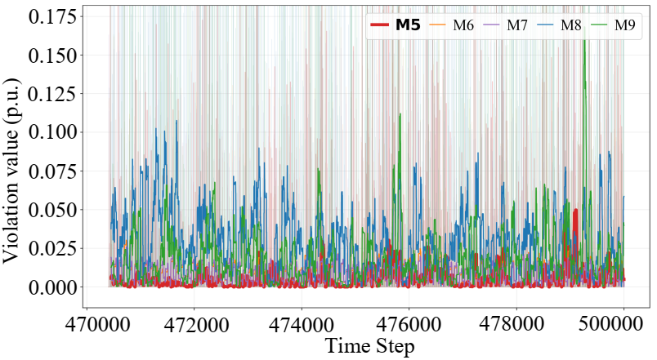 | 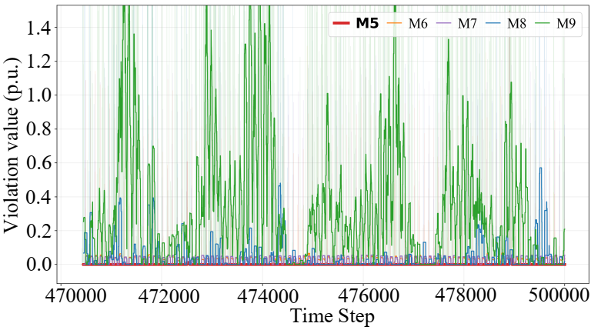
(d1) Maximal power flow violation of the last 100 episodes (33-bus) | (d2) Maximal power flow violation of the last 100 episodes (141-bus)
- Maximal voltage and branch power violation training curves of M5~M9 in the modified IEEE-33 and IEEE-141 bus system
As illustrated in Fig. 15(a), M5 (our proposed safe DRL-based method) achieves the fastest convergence rate among all compared methods. Meanwhile, Fig. 15(b) indicates that M5 yields the lowest daily average IPDEV, demonstrating its effectiveness in flexibility demand disaggregation. Moreover, in Fig. 16, the maximal $V$ and $S_{ij}$ violation per time step ($ΔT=15min$) during the last 100 episodes (1 episode = 1 training day) also remain at relatively low levels. Therefore, the training curves for return, violation metrics, and IPDEV versus environment steps demonstrate that M5 attains a favorable trade-off between economic efficiency and operational security throughout the training process.

